Job Description |  |  | 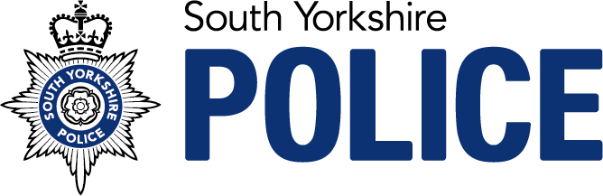
Job Title: Admin Team Leader
Service: | Occupational Health | Grade: | C
Reporting to: | Admin Team Manager | Location: | Escafeld House | Hours: 37

Role Purpose
The Admin Team Leader role resides within the Wellbeing Team and is critical to the core function of the overall wellbeing service. This role is customer focused and designed to support the admin and clinical teams to achieve a high standard of service delivery. With line management responsibility for a team of administrators, the Team Leader will ensure that the team receive support, conduct PDRs, encourage CPD and address any development needs. The role will be responsible for the workflow of referrals submitted to OHU, making sure KPIs are achieved in-line with service delivery agreements, maximising clinical utilisation and ensuring that all administration tasks are completed to a high standard on a daily basis.

Key Accountabilities
- Line management responsibility for a team of administrators including completion of team meetings, one-to-ones, PDRs, CPD, and addressing any development needs.
- Lead, develop, motivate and engage the Admin Team to enable a high standard of customer service.
- Ensure execution of daily admin tasks to a high standard such as scheduling appointments, reception duties, compiling files and scanning.
- Closely manage the referral process ensuring delivery against KPI’s, identify risks to delivery and take remedial action to mitigate service failure.
- Ensure maintenance of records on Origin, eOPAS and Chronicle and ensure that all records are clear and up to date with current status.
- Ensure appropriate advice is provided to clients through calls, e-mails and face-to-face enquiries.
- Support the clinical teams with day-to-day delivery of the service to ensure a smooth client experience.
- Supporting the Admin Team Manager with producing data reports and other information for stakeholders.
- Engage with visitors to site ensuring that they pass the required security checks and support site inspections.
- Monitoring daily workflow and highlighting issues to relevant clinicians.
- Management and co-ordination of response for complaints.
- Diary management of the occupational health advisory teams ensuring that service delivery KPIs are met and raising concerns with the OHU Senior Management Team.
- Work closely with TA Manager to monitor recruitment and ensure sufficient resources are available for delivery, highlighting risks to OH Admin Manager and Wellbeing Manager.
- Ensure all admin processes and policies are documented.
- Liaison with external parties and contractors.
- Ensuring the collation and reporting of client satisfaction information.
- Support the Admin Team Manager with any other tasks as directed.
- Undertake any other work as directed including working at different locations within South Yorkshire Police.

Skills |  | Education and Experience
- Management skills.  - Excellent customer service skills with a customer centric approach.  - Excellent communicator, verbal and written.  - Ability to organise themselves and work streams to a high standard.  - Self-motivated.  - Attention to detail and comfortable managing multiple tasks.  - Ability to use own initiative and make decisions.  - Continuous improvement mind-set by continually seeking improvements to policy, guidance and process to improve the customer journey. |  | - Line management experience.  - GCSE Maths and English.  - Experience of delivery in a customer service environment.  - Experience of use of electronic systems, email, word, excel etc.  - Experience of undertaking and managing administration duties.  - Experience of managing work streams and assisting in the achievement of KPIs.  - Understanding of client confidentiality and DPA.  - Experience of working in a medical/OH setting is desireable.
 |  | Our Competencies
The Competency and Values Framework (CVF) has 6 competencies that are clustered into three groups. This role should be operating, or working towards, the following levels

Resolute, compassionate and committed
Emotionally Aware - Level 2
Takes Ownership - Level 2

Inclusive, enabling and visionary Leadership
Works Collaboratively – Level 2
Delivers, supports and Inspires – Level 2

Intelligent, creative and informed policing
Analyses Critically – Level 2
Innovative and open-minded – Level 2

