Job Description |  |  | 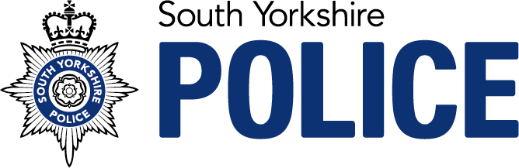
Job Title: Occupational Health Advisor
Service: | Occupational Health | Grade: | E
Reporting to: | Senior OHA | Location: | Escafeld House | Hours: 37

Role Purpose
The Occupational Health Advisor resides within the Wellbeing Team and is critical to the core function of the overall wellbeing service. The Occupational Health Advisor role is required to deliver a range of OH services to SYP, including attendance management, pre-placement assessments, fitness for work medicals, vaccinations, management of contamination incidents and other services as required. Working as part of a multidisciplinary team, OHAs will ensure that individuals have access to or are signposted to the support that they need to encourage attendance at work, manage any associated risks and to provide managers with guidance that will support a sustainable workforce.

Key Accountabilities
- Conduct telephone consultations and manage complex caseloads maintaining clinical objectivity and impartiality at all times in line with occupational health guidance.
- Provide appropriate and effective evidence based occupational health advice to support employees and management across South Yorkshire Police.
- Provide a concise report to management indicating an employee’s fitness to work and detailing any advisory reasonable adjustments with timeframes in line with audit criteria.
- Utilise a bio-psychosocial approach combined with functional assessment to address barriers to work and inform robust work recommendations.
- Work as part of a multi-disciplinary team and effectively manage each referral to ensure each client receives the expertise required for their particular circumstances.
- Obtain specialist reports where appropriate to do so and liaise with the Physician, Physiotherapist and Counsellors in order to provide robust occupational health reports that support an individual’s rehabilitation back to work and utilise relevant organisational policies to support effective return to work plans.
- Interpret legislation and contribute to policies, standards and procedures to meet South Yorkshire Police requirements for occupational health provision.
- Deliver occupational health services, which comply with confidentiality and codes of professional practice.
- Deliver pre-employment and mandatory medicals advising on fitness for work, providing details of work place adjustments for managers to consider and ensuring medicals are undertaken within agreed timescales to maintain frontline operational policing.
- Deliver health surveillance programmes as required, demonstrating competency in the required medical tests e.g. spirometry, audiometry etc.
- Supervise the delivery of health surveillance programmes carried out by the OHT, interpreting test results and providing any feedback to management.
- Undertake vaccination programmes and advise on infection control issues.
- Sensitivity and effectively manage contamination incidents.
- Participate in the process for permanency, ill health retirement, pension process for police officers and staff as required.
- Demonstrate good understanding and practical application of relevant health and safety regulations and know when to escalate cases of concern.
- Maintain accurate occupational health records in a safe and confidential manner through the eOPAS database in accordance with relevant legislation.
- Assist in the delivery of health promotion activities in line with the force’s Wellbeing Strategy.
- Provide individual advice on improving health and wellbeing, signposting to relevant external agencies/charities to help individuals access support and make lifestyle changes.
- Participate in regular peer clinical audit to generate continuous service improvements in quality.
- Be able to prioritise work with effective time management to ensure all tasks are completed accurately and within set timescales/KPIs.
- To undertake any other duties commensurate with the role.

Skills |  | Education and Experience
- Passion for excellence and high standards of client care.  - Excellent communication, influencing and relationship management skills.  - Excellent report writing skills.  - Ability to conduct medical assessments as required and deliver vaccinations.  - Proven ability to manage a challenging workload and support future Occupational Health Plans.  - Ability to travel within South Yorkshire Police to deliver an agile occupational health service. |  | - Professionally qualified in Occupational Health Nursing (Degree or Diploma, postgraduate qualification) – along with significant understanding and practical experience in the health sector.  - Case management experience.  - Competence in delivery of immunisations, venepuncture, audiometry, spirometry.  - Knowledge and understanding of health and wellbeing issues facing Policing.  - Proven ability to manage a challenging workload and support future OH plans.  - Thorough understanding and application of professional regulatory frameworks and their relevance to SYP occupational health services.
 |  | Our Competencies
The Competency and Values Framework (CVF) has 6 competencies that are clustered into three groups. This role should be operating, or working towards, the following levels

Resolute, compassionate and committed
Emotionally Aware - Level 2
Takes Ownership - Level 2

Inclusive, enabling and visionary Leadership
Works Collaboratively – Level 2
Delivers, supports and Inspires – Level 2

Intelligent, creative and informed policing
Analyses Critically – Level 2
Innovative and open-minded – Level 2

