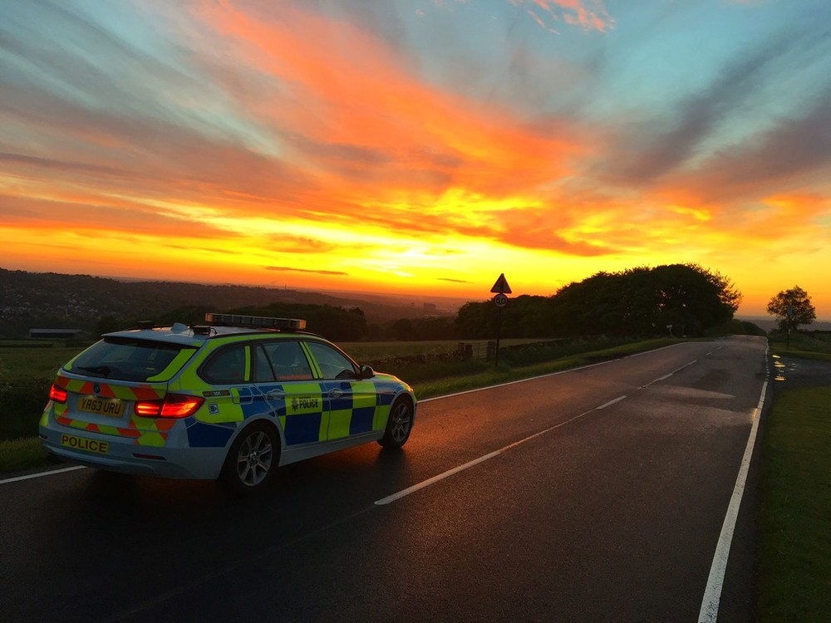

**South Yorkshire Police**

**Transferee Application Form Guidance**



**Guidance Notes for Transferee Applicants**

You should read these notes thoroughly before completing the online application form. When submitting your online application form, you must also submit the following documents to: [policerecruit@southyorks.pnn.police.uk](mailto:policerecruit@southyorks.pnn.police.uk)

* 2 most recent PDR’s / Appraisals
* Copy of FULL training record
* Photographs of ALL tattoos. Please note, you can attach 4 images to your online application form, please email us any additional images.

|  |
| --- |
| **Eligibility to apply** |
| Any officer wishing to transfer must:   * Have completed their probation period and be confirmed in post * Have no outstanding / open complaints * Not have any tattoos which do not meet the Force dress code standards (No tattoos on head, face, neck or hands). Tattoos which could be deemed inappropriate or cause offence will not be accepted * Have completed all mandatory training and this must be in date at the time of appointment * Meet vetting requirements * Must be fit for the role, this will be assessed by medical records, completion of a medical form and an appointment with occupational health for any officer successful at interview * Meet South Yorkshire Police’s attendance criteria. Sickness records will be requested if successful at interview |
| **Eligibility continued…..** |
| Consideration will be given to applications for level transfer from all England and Wales police forces for appointment to the rank of Constable, Sergeant or Inspector. Officers above these ranks will only be accepted following advertisement and assessment in accordance with the published selection process.  Applicants must have successfully completed Initial Police Learning Development Programme (IPLDP).  Applicants for the Detective roles must have completed the Initial Crime Investigators Development Programme (ICIDP) or equivalent and be PIP Level 2 qualified unless otherwise advertised.  Transfer requests from the following are assessed on a case by case basis**:   * British Transport Police (BTP) * Police Service Northern Ireland (PSNI) * Police of Scotland * Ministry of Defence (MoD)   **Officers from the above forces may need to undergo the initial Student Officer training course if required.  Transfer requests from the following are not accepted:   * Civil Nuclear Constabulary (CNC) |
| **Transferee recruitment & selection process** |
| The transferee recruitment process is comprised of the following:   * Completion and shortlisting of application and supporting documents * Competency based interview (if you are unsuccessful at interview, you will be able to re-apply after 6 months unless advised otherwise) * Completion of pre-employment checks (vetting, medical, references, attendance criteria, substance misuse testing & bio metrics, fitness test)   Process after successful completion of recruitment stages:   * Issue of Appointment Letter * Issue of collar number * Uniform fitting appointment * Initial induction course (usually 8 days) – then start on shift |
| **Competency & Values Framework for Policing (CVF)** |
| The selection process includes assessment against the CVF. It is important that during your interview, you do not simply provide statements but that you provide clear evidence and examples to demonstrate how you meet the competencies set out in the CVF. The competency level for Constables and Sergeants is Level 1, for Inspectors and Chief Inspectors is Level 2 and higher ranks are Level 3. |
| **Training Record & Skills** |
| It is important that you complete these sections of the application in full and it must include dates each area of training has been completed. Any mandatory training must have been completed prior to appointment so it is important that if you are, for any reason, out of date with any mandatory training that you ensure you arrange for this to be completed. |
| **Business Interests** |
| You must declare any business interests you have.  Any business interest will have to be approved and registered by Professional Standards Department (PSD) in order for you to continue with it. |
| **Tattoos & Facial Piercings (existing & new)** |
| All tattoos and piercings must be in line with South Yorkshire Police’s Appearance and Standards Policy. Photographs must be provided with your application where applicable.  Tattoos that are visible in normal duty uniform i.e. face, scalp, ears, neck, hands and forearms or visible in an open collared / short sleeved shirt are not considered appropriate and will not be accepted. Any tattoos which could be deemed inappropriate or cause offence will also not be accepted.  Once you have submitted your application it is important that you make the Recruiting Team aware if you are considering obtaining any new tattoos or piercings. Any new tattoos or piercings which do **not** fall in line with the Policy will result in your application being withdrawn. |
| **Disability & Health** |
| Applicants must be in good health, of sound constitution and able to both physically and mentally perform the duties once appointed.  Officers are covered by the Disability Discrimination Act and if you do have a disability, we will endeavour to make adjustments which it is reasonable to do so. Please provide any relevant information about any disability with your application. Disability is determined as ‘a physical or mental impairment, which has a substantial and long-term adverse effect on the ability to carry out normal day-to-day activities’. |
| **Vetting** |
| If successful at interview you will be required to complete a vetting process. The level of vetting will be determined by the position you are being progressed for. It will include vetting checks being made with your current Force and checks on misconduct and complaints. Your application will be put on hold if you have any open complaints in your current Force, and will be reviewed once the case is closed. |
| **Appointment** |
| Although consideration is given to any posting preference given, please note that any officer joining South Yorkshire Police must be prepared to work anywhere within the Force area.  Organisational needs and priorities will determine where the vacancies are. |
| **Relocation/Removal Expenses** |
| In order to support the financial costs associated with transferring the Chief Constable has agreed to offer relocation/removal expenses to transferring officers who at the time of their offer of employment live outside of the Force area and at least 50 miles from their permanent place of work. (This does not include any furniture, household items, and solely relates to Estate Agent/Solicitors fees etc). There is a force relocation policy, summarised below.  An officer is able to claim the costs associated with buying and selling a property and removal costs within 12 months of their appointment up to a maximum of £8,000.  If an officer in receipt of relocation expenses were to leave within 3 years of joining he/she would be required to repay the expenses paid under this provision in the following proportions:  Leaving during year 1:  100% of the relocation costs paid  Leaving during years 2 and 3:  100% of the costs less 1/24th for each completed month served |
| **Important Notes** |
| Once you have submitted your application, it is important that you make the recruitment team aware of any changes to your circumstances. This includes changes to your address, phone number, email address, misconduct and complaints issues, new tattoos, training, business interests etc. |
| **Finally…..** |
| We look forward to receiving your application to transfer to South Yorkshire Police.  In the meantime, if you have any other queries please do not hesitate to contact the recruiting team by email: [policerecruit@southyorks.pnn.police.uk](mailto:policerecruit@southyorks.pnn.police.uk) |